Name

Mathematics Stage 5 Core
Volume of
Composite Solids

Book 1 |  | Version: 261002  Feedback:  https://MrDingMaths.com
Contents
Syllabus Content 2
Learning Intention 3

Syllabus Content
MA5-VOL-C-01 solves problems involving the volume of composite solids consisting of right prisms and cylinders
Solve problems involving composite solids consisting of right prisms and cylinders
- Find the volumes of composite right prisms with uniform cross-sections that may be dissected into triangles and quadrilaterals
- Find the volumes of right prisms that have uniform cross-sections in the form of sectors, semicircles and quadrants
- Calculate volumes of composite solids consisting of right prisms and cylinders
- Solve practical problems related to the volumes and capacities of composite solids

Volume of Composite Solids

- Review
- Calculate the volume of these solids using $V=Ah$.
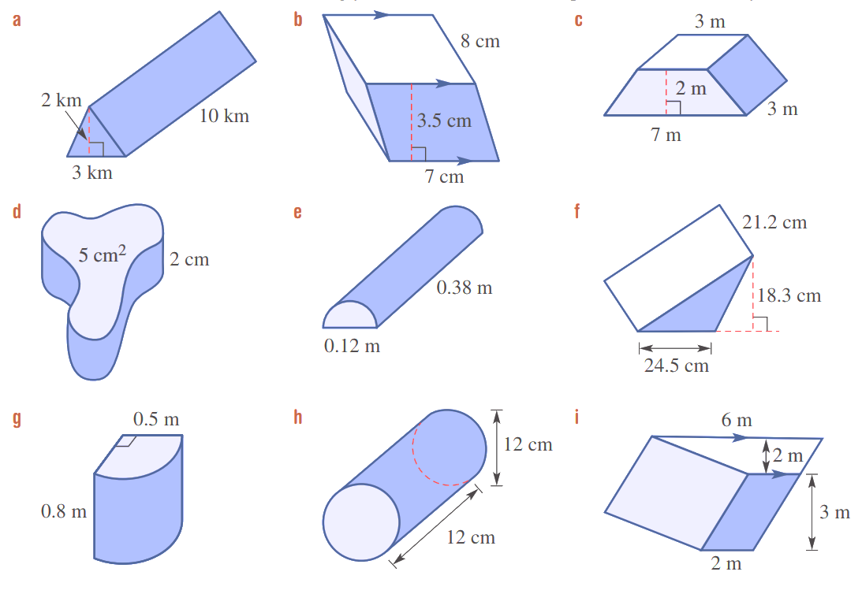  Area of base:  $A=$ $\frac{bh}{2}$  $=$  $=$  Volume:  $V=Ah$  $=$  $=$  30 km³ | Area of base:  $A=$ $bh$  $=$  $=$  Volume:  $V=Ah$  $=$  $=$  196 cm³ | Area of base:  $A=$ $\frac{h(a+b)}{2}$  $=$  $=$  Volume:  $V=Ah$  $=$  $=$  30 m³
10 cm³ | 1357.2 cm³ | 4752.5 cm³
0.157 m³ | 0.00215 m³ | 24 m³

- Volume of Composite Solids
- A composite solid is made up of multiple simple solids.
- To find the volume of composite figures, add or subtract the volumes of simple solids.
- Split the composite solid into simple solids.
- Calculate the volume of each simple solid.
- Add or subtract the volumes.

- Example Success Criteria
Calculate the volume of these prisms. Round your answer to 2 d.p.
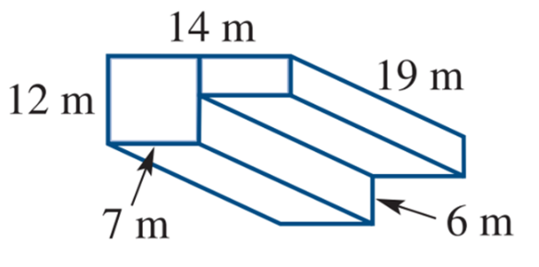  $V_{1}=Ah$  $=\left(12×7\right)×19$  $=1596$  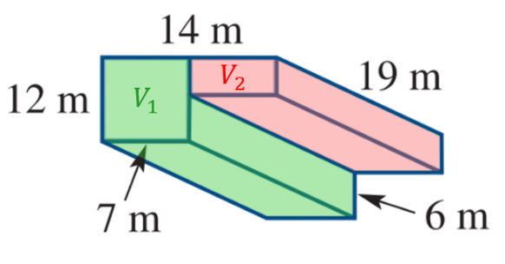  $V_{2}=Ah$  $=\left(6×7\right)×19$  $=798$  $V_{tot}=V_{1}+V_{2}$  $=2394 m^{3}$ | $V_{1}=Ah$  $=\left(12×7\right)×19$  $=1596$  $V_{2}=Ah$  $=\left(6×7\right)×19$  $=798$  $V_{tot}=V_{1}+V_{2}$  $=2394 m^{3}$

- Guided Practice
Calculate the volume of these composite prisms
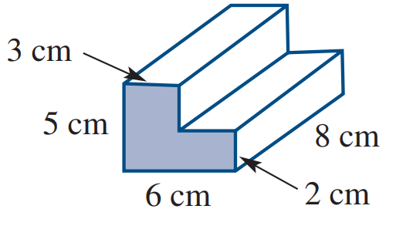  $V_{1}=$  $V_{2}=$  $V_{tot}=$  168 cm³ | 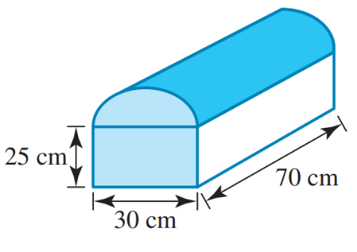  77240 cm³ | 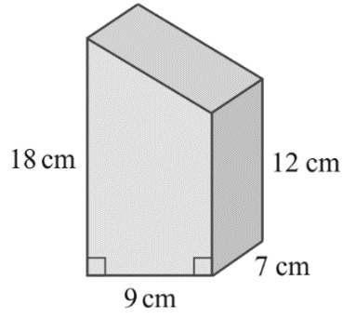  945 cm³

Foundation
- Calculate the volume of these solids by adding the volumes of the two solids it is made from. The measurements are in centimetres. Round your answers to 1 d.p.
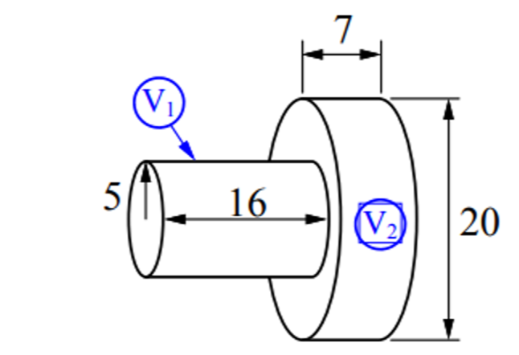  $V_{1}=πr^{2}h$  $=$  $V_{2}=πr^{2}h$  $=$  $V_{tot}=$ ……… $+$ ……… $=$ …………  3455.8 cm³ | 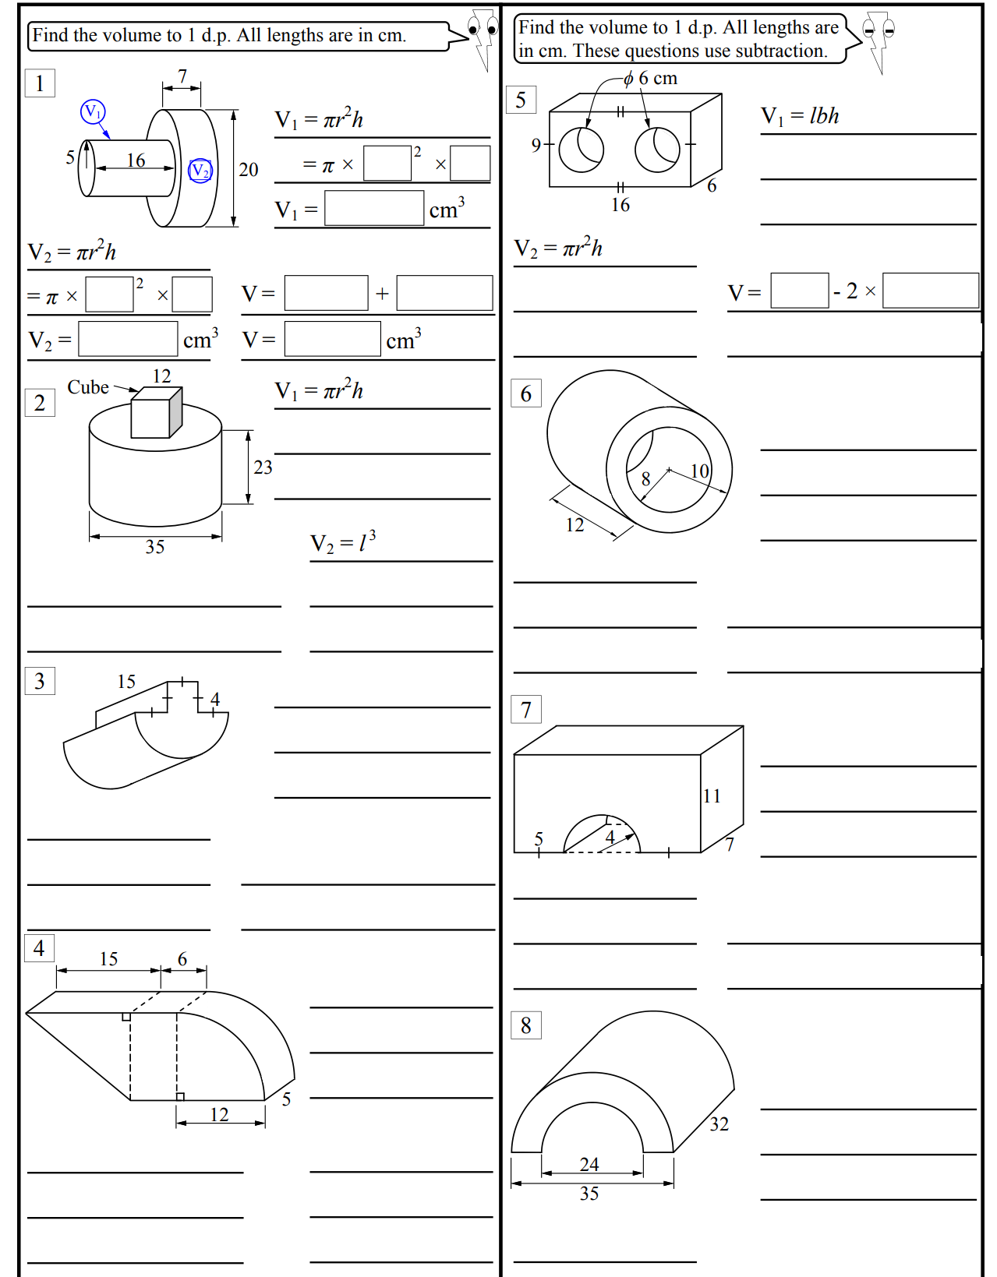  $V_{1}=l^{3}$  $=$  $V_{2}=πr^{2}h$  $=$  $V_{tot}=$ ……… $+$ ……… $=$ …………  23 856.6 cm³

- Calculate the volume of these prisms by addition. Round to 1 d.p. where appropriate.
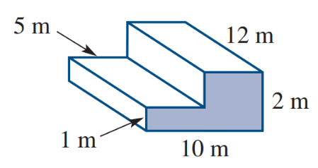  180 m³ | 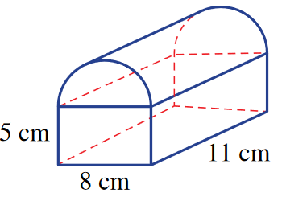  716 cm³ | 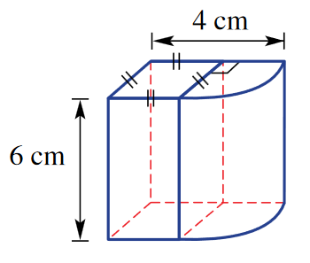  43 cm³
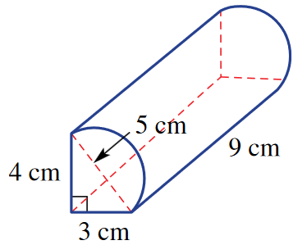  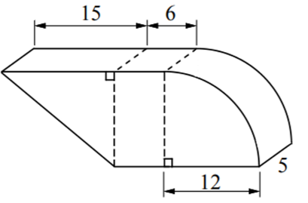  142 cm³ | 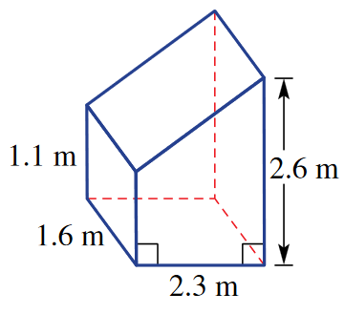  6.8 m³ | 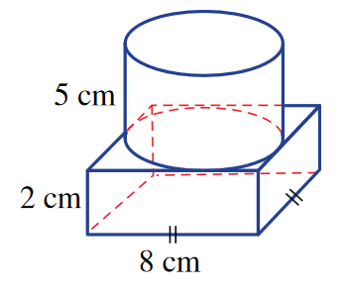  379.3 cm³

- Calculate the volume of these solids. If units are not shown, they are in cm. Round to 1 d.p.
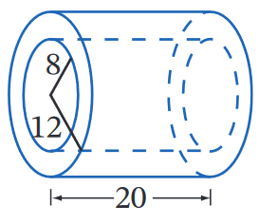  5026.6 cm³ | 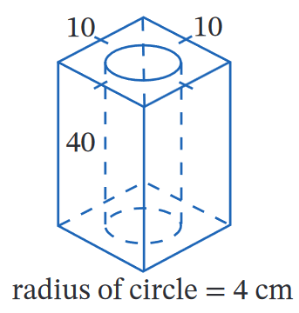  1989.4 cm³ | 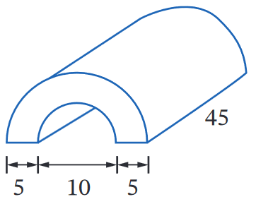  5301.4 cm³
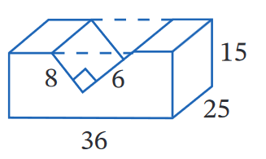  12 900.0 cm³ | 1210.1 cm³ | 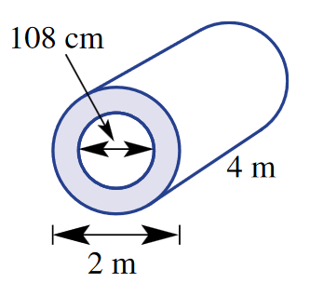  8.9 m³

- Calculate the volumes of these shapes. All lengths are in cm. Round answers to 1 d.p.
- A stack of 3 cubes  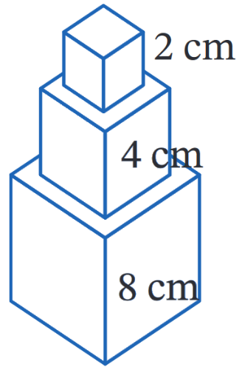  584.0 cm³ | 1088.2 cm³ | 1375.5 cm³

Development
- Calculate the volume of these solids. Answer to 1 d.p.
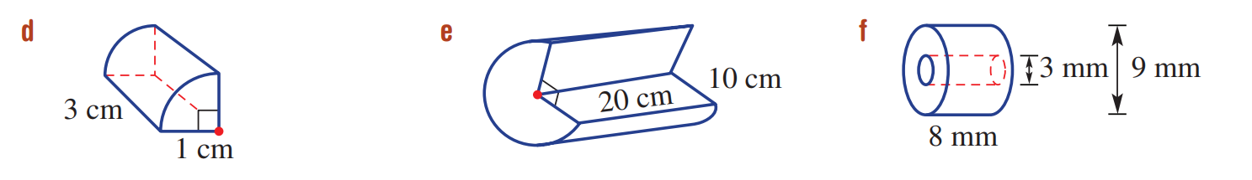  2.4 cm³ | 4712.4 cm³ | 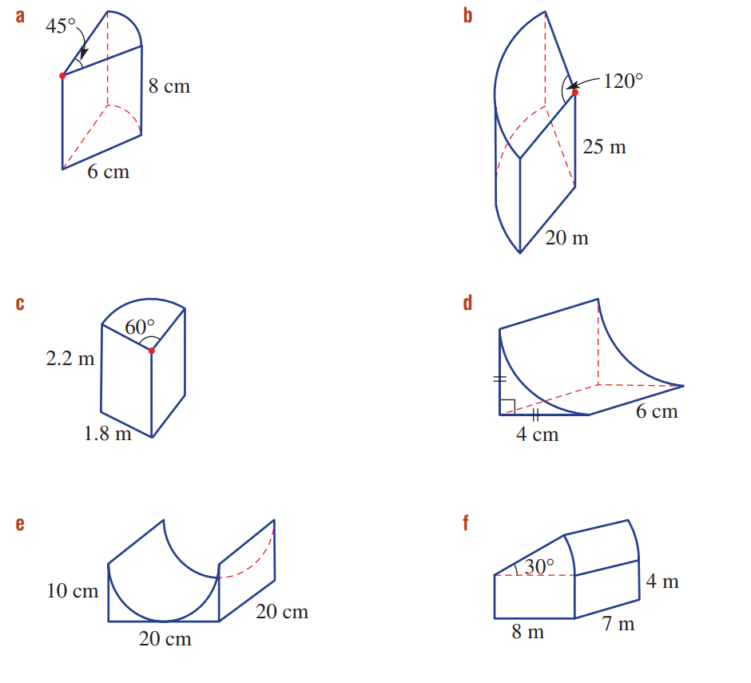  858.4 cm³ | 20.6 cm³

- The given diagram is a sketch of a new 25 m swimming pool to be installed in a sports complex.
  - Find the area of one side of the pool (shaded).
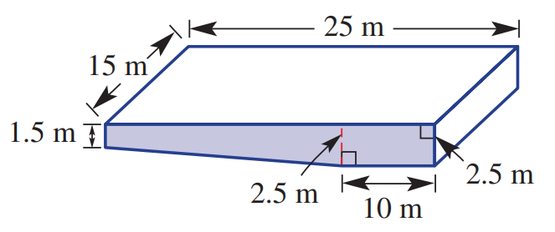

55 m²
  - Find the volume of the pool in cubic metres.

825 m³
  - Find the capacity of the pool in litres, if 1 m³ = 1000 L

825 000 L
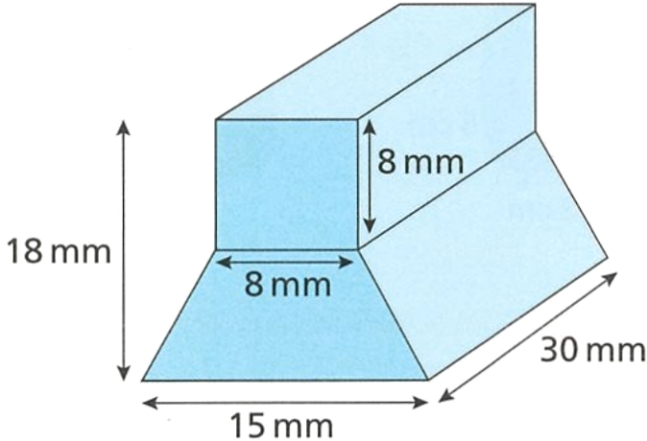
- Calculate the volume of this prism.

5370 mm³

Mastery
- Using the area of a sector $A=\frac{θ}{360}×πr^{2}$, calculate the volume of these solids to 1 d.p.
113.1 cm³ | 10 472.0 m³ | 3.7 m³ | 341.3 m³

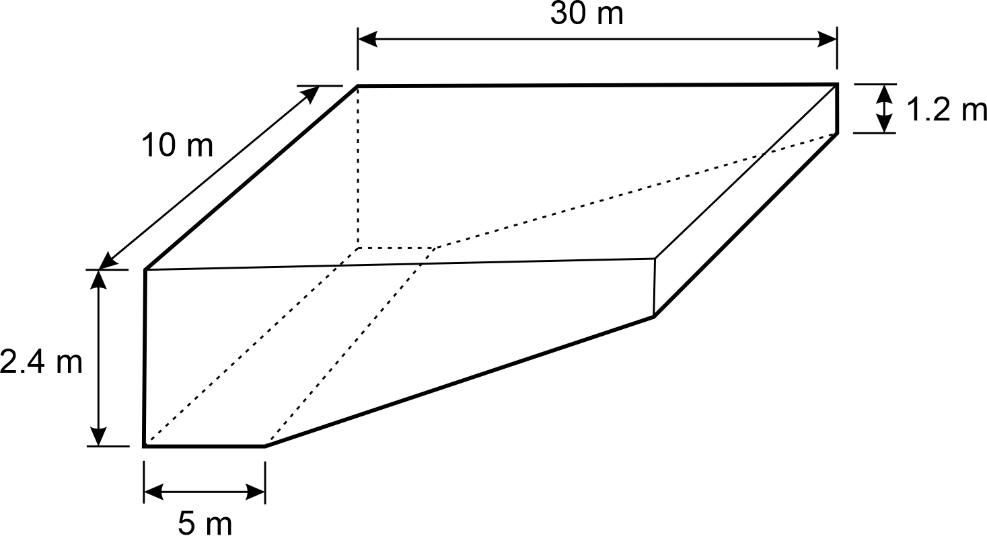
- Calculate the volume of earth that must be excavated so that the pool shell below fits exactly into the hole.

570 m³
- Enzo is building a 20 m long tunnel that has a 6 m wide semicircle for a cross section.
The tunnel is to be built using concrete that needs to be 1 m thick.
How many cubic metres of concrete does Enzo need to build the tunnel, correct to 3 d.p.?
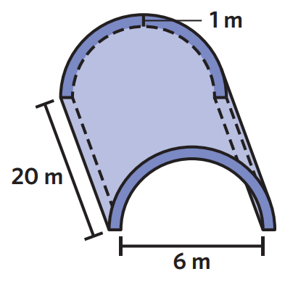

219.911 m³
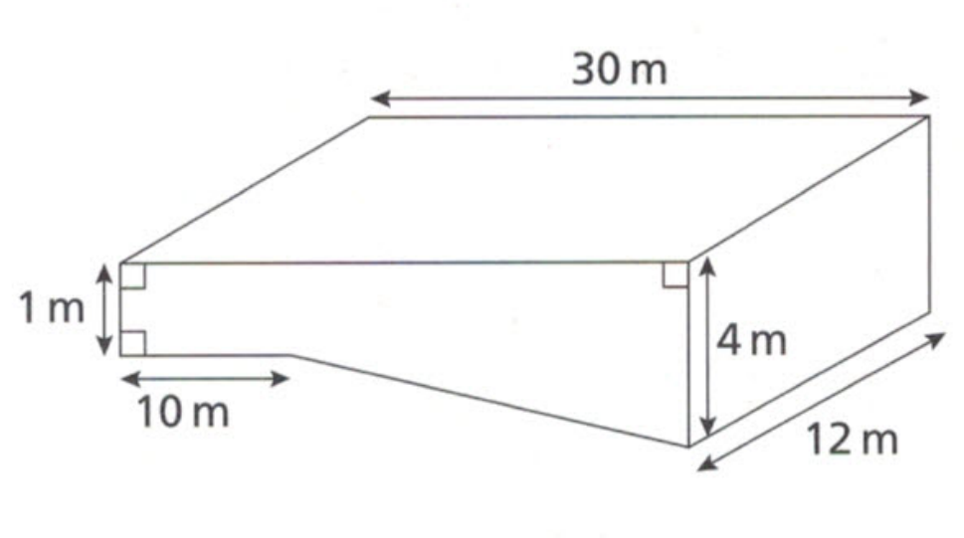
- The diagram shows an empty swimming pool.
Water flows into the pool at a rate of 600 litres per minute.
How long, in hours and minutes, will it take to fill the pool? (Hint: 1000 L = 1 m³)

20 hours
- Consider this isosceles triangular prism with a hole through the middle.
  - Calculate $y$ using Pythagoras’ theorem.
  - Hence, show the volume is approximately 10 583 cm³
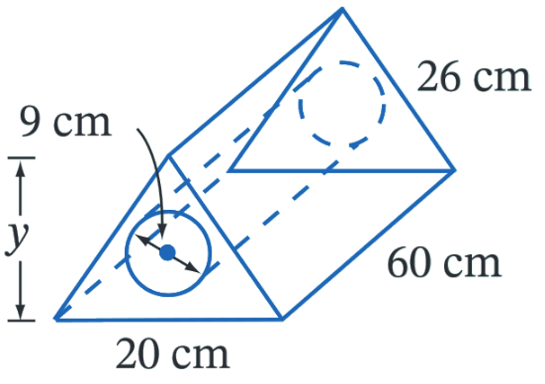

- A concrete support column is made up of a cylindrical base and a square prism.
The cylindrical base is 1 m in diameter and 1 m high,
and the square prism is 10 m long and sits on the cylindrical base.
  - Find the exact side length of the square base of the prism.
  - Hence show that the volume is approximately 5.8 m³
